How to install Docker on Debian 11

By Emmanuel
Updated:
Share
Docker is an open platform tool that offers a container run time environment. With the help of this software, programmers can develop, ship, and execute their code as a container anywhere, like on-prem or public cloud. Docker utilizes OS-level virtualization to spin up containers. Docker Engine is the host on which the Docker is installed, and containers are spun.
If you are an app developer who desires to operate under an open-source environment, you will appreciate what Docker offers in Debian version 11(Bullseye). To add on, this software makes the delivery faster because targeted apps and their preferred development infrastructures are sovereign of each other.
Docker takes control of the software development and testing infrastructure, whereas developers manage actively running apps or those still undergoing development. As such, Docker’s methodology ominously decreases the timeline between writing functional code and getting it ready for production. It results in speedy testing, shipping, and deployment of application codes.
The Docker project has basically made it easier for DevOps to package their apps as a “build once and run anywhere” strategy, meaning you create an app once, and it can run or execute anywhere.

The Docker Container
You can think of them as executable images. With Docker Application Programming Interface (API) or Command Line Interface (CLI), you can carry out diverse operations in a Docker container. It also allows you to connect a container to one or more networks, accord any storage on it, or create a new Docker image from an already existing state.
A container is habitually well separated from its host and default machine. You have jurisdiction over the private network of a container, its storage, and other fundamental subsystems. The image of a container and any conformation constraints you offer is utilized in creating or initializing it. Any alterations or modifications to a container’s state that are not saved in persistent storage are lost upon the container removal.

Below are some of the terminologies/Docker components
Docker container: This is a running sample of a docker image with an application and its dependencies. It is important to note that each container has a distinctive identification (ID) and is secluded from other containers. One thing containers share is the kernel.
Docker Client: This is a command-line tool the user uses to interact with the Docker daemon.
Docker daemon: Also known as Docker Engine. It refers to a background process that runs on the host system responsible for generating and running containers.
Docker registry: This is an app responsible for managing the storage and delivery of Docker container images. It can either be private or public.
Docker image: This is an immutable file just a screenshot of a container. A docker image contains a file system and app dependencies needed for running apps.
Prerequisites:
- User with sudo rights
- 64-bit system
- Stable network connection
- Minimal Debian 11 installation

Installing Docker on Debian 11

Step 1: How to install Docker Dependencies
First, open up your terminal using “CTRL+ALT+T” and run the following command that will ensure your system is up to date:
sudo apt-get update

Next, we will append the required Docker dependencies to the Debian system using the following command:
sudo apt -y install apt-transport-https ca-certificates curl gnupg2 software-properties-common

Note: Ensure there is a successful installation of the dependencies for the proper running of the software.

Step 2: Add Docker’s official GPG key:
Before setting up the repository for downloading and installing docker packages, you are required to append Docker’s official GPG key in the Keyrings. The main objective of this key is to ensure the validity of downloaded docker packages. To attain this, run the following command:
sudo su
curl -fsSL https://download.docker.com/linux/debian/gpg | gpg --dearmor -o /usr/share/keyrings/docker-archive-keyring.gpg

Step 3: Add stable repository
In this phase, you need to add the stable repo using the following command to download the current version of docker packages. So we will set up the repo
echo "deb [arch=amd64 signed-by=/usr/share/keyrings/docker-archive-keyring.gpg] https://download.docker.com/linux/debian $(lsb_release -cs) stable" | sudo tee /etc/apt/sources.list.d/docker.list

Step 4: Update Package Cache
After appending repo info, you need to update the packages cache with all the package info from the newly added repo using the apt command as shown below:
apt-get update

Step 5: Install Docker Engine
Next, download and install the latest version of the Docker engine and container using the following command:
apt-get install docker-ce docker-ce-cli containerd.io

Step 6: Check Docker Version
After successful installation, you can run the following command:
docker –version
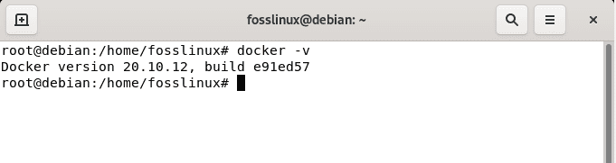

Step 7: Check Docker Service
The next step is to check the Docker status after a successful installation. We will do this using the “systemctl” command. This command is used to control various services in a system. In our course, we will run the “systemctl” command with the “status” option to see if the Docker service is active or inactive on our Debian system:
sudo systemctl status docker
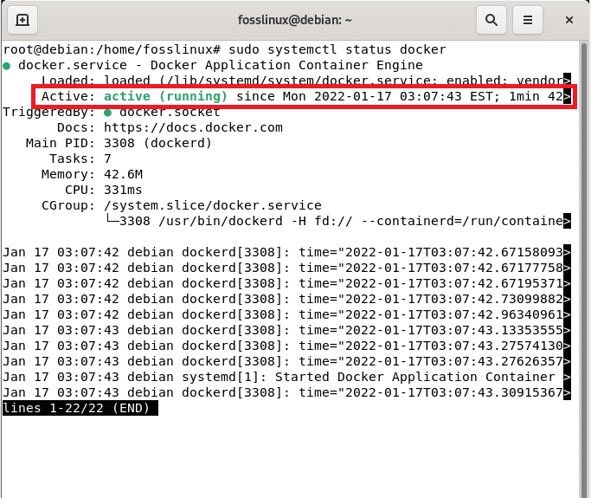
If the Docker is active, like in our case, you should see an active (running) green writing as highlighted in the snapshot above.
The Docker service will automatically start after setup, but you can always check using the systemctl status docker command we earlier covered. If obligatory, you can also start the service using the systemctl start docker command or restart the service by using the systemctl restart docker command:

Step 8: Test Docker
To this far, we have now installed Docker and checked its status on our Debian system. Now, what next? You may ask. We will examine the functioning of Docker by executing a sample container. In essence, we will try to run a “hello-world” global docker container.
Run Hello World Image
You can now use the docker engine to create your first container from the hello-world image. This can be achieved by running the hello-world command as shown below:
docker run hello-world
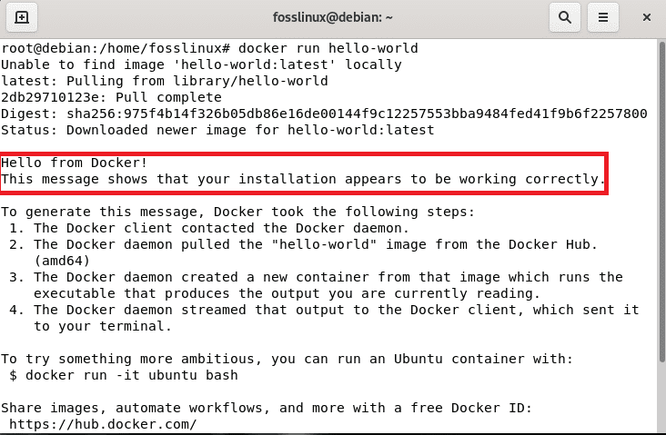

Step 9: List Docker Images
Next, you can run the list of all the available images using the docker images command. Please take note of the resemblance between the docker images command and the docker image command, as they both serve different purposes. You can utilize the docker image <command> syntax if you anticipate managing your Docker images. Conversely, this is not the case as we want only to list the images. As such, run the following command:
docker images
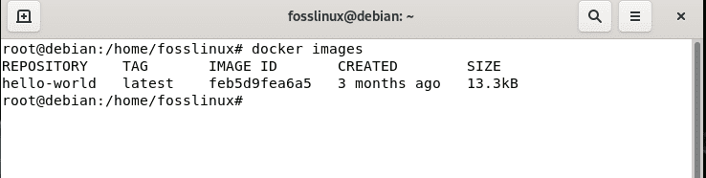

Step 10: Run a Ubuntu Container
Here you can utilize the docker run -it ubuntu bash command to run a Ubuntu Container. If you don’t provide a particular tag with the image, it will by default search for ubuntu: latest image. In cases where the image is not available in your local system, it will be downloaded from the Ubuntu Library then the container will be created using that image. To attain this, run:
docker run -it ubuntu bash
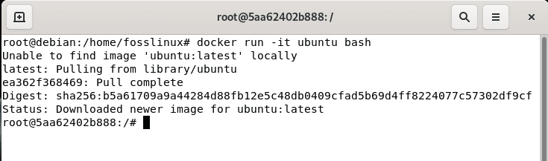

Step 10: List Docker Containers
To list all the containers embedded in this software, use the following command to list all the containers regardless of their state.
docker ps -a
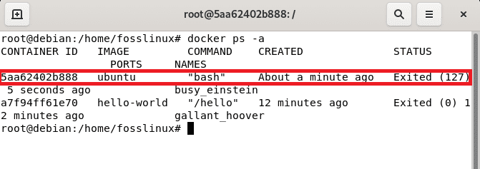

Step 11: Manage Docker Containers
In case you want to initialize a container, then you need to use the following syntax:
docker start <container_id>
For instance, you can start a container with, say, ID 5aa62402b888 for the ubuntu bash we created, as shown in the snapshot below:
docker start 5aa62402b888

Then, run the ps command to check the status of the container
docker ps
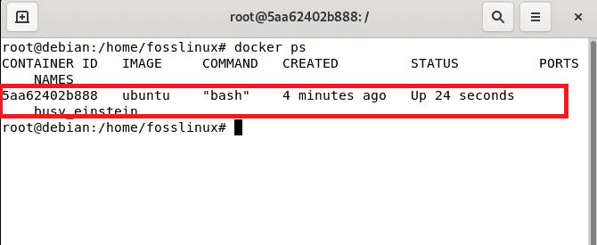
Correspondingly, if you want to stop a container, you can make use of the following syntax:
docker stop <container_id>
In essence, we want to stop the Ubuntu bash Container with ID 5aa62402b888. Here, we will run the above-given syntax substituting the <container_id> section with our running container’s actual id as displayed below:
docker stop 5aa62402b888

Then again, use the ps command as earlier covered to check the status:
docker ps
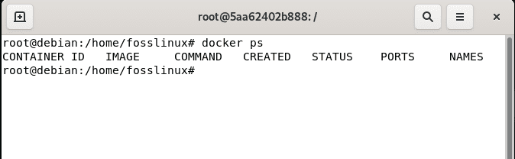
As you can see, the container with ID 5aa62402b888 is not running anymore.
Also, you can delete the image using the following image syntax:
rm <container_id>
In this event, we are removing the container with ID 5aa62402b888 as shown below:
docker rm 5aa62402b888
Now check the list of images using the docker images command, and you should see that container with ID 5aa62402b888 is no longer available:
docker images

Step 12: Push Images to Docker Hub Repository
In cases where you want to store images in repositories like Docker Hub Repository, you first need to log in to that repository using your user account credentials. If you don’t have an account, you can Sign up here. After that, log in using the following command:
docker login
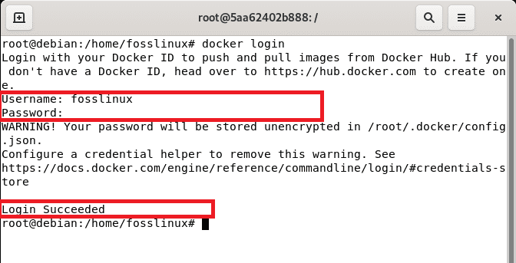
Afterward, key in your username and password and press enter to log in. For the approval of a successful login, you should see a “Login Succeeded” message at the bottom. Now that you have successfully signed in, you can now push your images using the following syntax:
docker push <Image_name>
It is critical to note that you may need to tag the image before pushing it to Docker Hub Repository.

Step 13: Remove Docker
To erase the docker engine from the system, we need to uninstall the Docker Engine, CLI, and Containerd packers using the following command:
apt-get remove docker-ce docker-ce-cli containerd.io

Note that images, containers, volumes, or customized configuration files on your host are not spontaneously removed. As such, you have to manually delete all images, containers, and volumes using the following commands:
sudo rm -rf /var/lib/docker
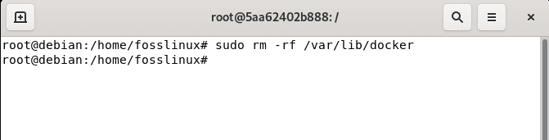
Remove containerd using:
sudo rm -rf /var/lib/containerd

Benefits of Docker
One of the critical profits of using an open-source project software like Docker is the freedom to choose the technology you want to use to finish up any task. Docker is suitable for programmers who need a small size, lightweight, and clean environment for testing purposes and desire to avoid extensive management and configurations.
The software can also test, ship, and deploy code quickly, which aids reduce the delay between writing code and executing it in an environment.

Final Thoughts
Docker is a framework software used to generate, test, and develop apps quickly. This software arranges apps or packages into containers, including all that your application needs to function, like system tools, runtime, libraries, and code. Docker allows you to deploy and scale applications in any environment promptly.
This article has deeply covered how one can set up Docker on their Debian 11 system from the fundamental point to the complex point of uninstalling the software. Besides installation, we have equipped you with the basic commands that you will encounter in your day-to-day activities with this software. That’s it, guys. We hope you enjoyed reading.
https://www.fosslinux.com/49959/install-docker-on-debian.htm

Install Docker CE and Docker Compose on Debian 11/10
By
Josphat Mutai
-
75880
8
How do I install Docker CE on Debian 11/10?, How can I install Docker Compose on Debian 11/10 Linux system?. In this guide, I’ll discuss a step by step installation of Docker and Docker Compose on Debian 11/10.

Docker is the most popular and widely used container runtime. It enables you to package and run your applications in isolated containers in a single server or cluster of Linux servers orchestrated by Kubernetes and similar tools.

Docker Editions
There are two editions of Docker available.
- Community Edition (CE): ideal for individual developers and small teams looking to get started with Docker and experimenting with container-based apps.
- Enterprise Edition (EE): Designed for enterprise development and IT teams who build, ship, and run business-critical applications in production at scale.
This guide will cover installation of Docker CE on Debian 10 / Debian 11 Linux. But let’s first look at common docker terminologies.

Docker Components / Terminologies
Below are commonly used terminologies in Docker ecosystem.
- Docker daemon: This is also called Docker Engine, it is a background process which runs on the host system responsible for building and running of containers.
- Docker Client: This is a command line tool used by the user to interact with the Docker daemon.
- Docker Image: An image is an immutable file that’s essentially a snapshot of a container. A docker image has a file system and application dependencies required for running applications.
- Docker container: This is a running instance of a docker image with an application and its dependencies. Each container has a unique process ID and isolated from other containers. The only thing containers share is the Kernel.
- Docker registry: This is an application responsible for managing storage and delivery of Docker container images. It can be private or public.

Install Docker CE on Debian 11 (Bullseye) / Debian 10 (Buster)
Follow the steps covered in the next parts of this article to install and use Docker CE on Debian 11/10.

Step 1: Install Dependency packages
Start the installation by ensuring that all the packages used by docker as dependencies are installed.
sudo apt update
sudo apt -y install apt-transport-https ca-certificates curl gnupg2 software-properties-common

Step 2: Add Docker’s official GPG key:
Import Docker GPG key used for signing Docker packages.
curl -fsSL https://download.docker.com/linux/debian/gpg | sudo apt-key add -

Step 3: Add the Docker repository to Debian 10 / Debian 11
Add Docker repository which contain the latest stable releases of Docker CE.
sudo add-apt-repository \
"deb [arch=amd64] https://download.docker.com/linux/debian \
$(lsb_release -cs) \
stable"
This command will add the line shown in /etc/apt/sources.list file.
deb [arch=amd64] https://download.docker.com/linux/debian buster stable

Step 4: Install Docker & Docker Compose on Debian 11/10
Update the apt package index.
sudo apt update
To install Docker CE on Debian, run the command:
sudo apt -y install docker-ce docker-ce-cli containerd.io
Start and enable docker service:
sudo systemctl enable --now docker
This installation will add docker group to the system without any users. Add your user account to the group to run docker commands as non-privileged user.
sudo usermod -aG docker $USER
newgrp docker
su – ribafs
exit
Check docker and compose version.
$ docker version
Client: Docker Engine - Community
Version: 20.10.12
API version: 1.41
Go version: go1.16.12
Git commit: e91ed57
Built: Mon Dec 13 11:45:48 2021
OS/Arch: linux/amd64
Context: default
Experimental: true

Server: Docker Engine - Community
Engine:
Version: 20.10.12
API version: 1.41 (minimum version 1.12)
Go version: go1.16.12
Git commit: 459d0df
Built: Mon Dec 13 11:43:56 2021
OS/Arch: linux/amd64
Experimental: false
containerd:
Version: 1.4.12
GitCommit: 7b11cfaabd73bb80907dd23182b9347b4245eb5d
runc:
Version: 1.0.2
GitCommit: v1.0.2-0-g52b36a2
docker-init:
Version: 0.19.0
GitCommit: de40ad0
Log out and log back in so that your group membership is re-evaluated.
exit

Install Docker Compose on Debian
Use the guide below to install latest Docker Compose on Debian 10 / Debian 11
- How To Install Latest Docker Compose on Linux

Step 5: Test Docker installation
Run a test docker container:
$ docker run --rm -it --name test alpine:latest /bin/sh
Unable to find image 'alpine:latest' locally
latest: Pulling from library/alpine
cd784148e348: Pull complete
Digest: sha256:46e71df1e5191ab8b8034c5189e325258ec44ea739bba1e5645cff83c9048ff1
Status: Downloaded newer image for alpine:latest

/ # cat /etc/os-release
NAME="Alpine Linux"
ID=alpine
VERSION_ID=3.14.2
PRETTY_NAME="Alpine Linux v3.14"
HOME_URL="https://alpinelinux.org/"
BUG_REPORT_URL="https://bugs.alpinelinux.org/"

/ # exit

Step 6: Test Docker Compose installation.
Create a test Docker Compose file.
$ vim docker-compose.yml
Add below data to the file.
version: '3'
services:
web:
image: nginx:latest
ports:
- "8080:80"
links:
- php
php:
image: php:7-fpm
Start service containers.
$ docker-compose up -d
Output:
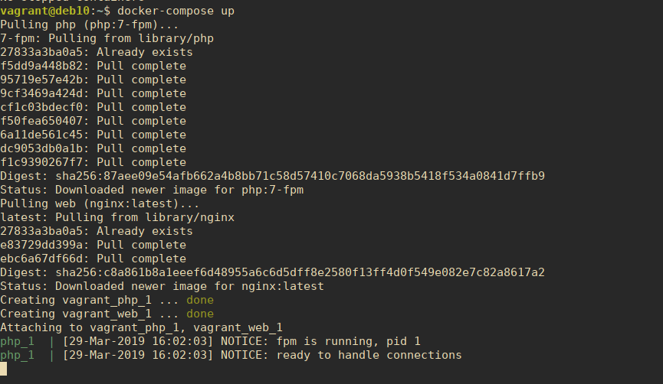
Show running Containers
$ docker-compose ps
Destroy containers
$ docker-compose stop
$ docker-compose rm
Going to remove vagrant_web_1, vagrant_php_1
Are you sure? [yN] y
Removing vagrant_web_1 … done
Removing vagrant_php_1 … done
You have successfully installed Docker on Debian 10 / Debian 11 Linux. Go through Official Docker documentation and Docker Compose documentation to learn more.

Setup Docker UI (Optional)
If you need a UI management console for Docker hosts and containers, checkout Portainer.
- How to Install Portainer Docker UI manager

Monitoring Docker containers
Monitoring Docker containers can be achieved by using Monitoring tools such as Netdata, Prometheus and Grafana. Below guide should also be helpful Check Container container metrics with Ctop.
https://computingforgeeks.com/install-docker-and-docker-compose-on-debian/

How to Install and Use Docker Compose on Debian 11
Docker-compose is a tool of docker, but before understanding what is the docker-compose let us explain what is a Docker? Docker is a virtual container that is used to combine the applications with their dependencies to run on any operating system. Docker supports a tool which is known as Docker-compose and is used to handle multi-container applications.
The Docker-compose uses the YAML files for configuration and it manages all the services from the CLI (command-line interface) either it is to start the service or to create the process, all the processes can be handled easily using this tool.
In this write-up, we will learn the installation procedure of its installation in Debian 11 and also discuss some basic commands of its uses.

How to install Docker-Compose on Debian 11
As the package of Docker-Compose is not comes along with the repository of Debian 11, so we will directly install it from Github and use the flag -o as output and store the output at the path provided, to do so we will execute the command:
$ sudo curl -L https://github.com/docker/compose/releases/download/v2.0.1/docker-compose-linux-x86_64 -o /usr/local/bin/docker-compose

Once the Docker-Compose has been downloaded and installed, we will change the access permissions of the file using the chmod:
$ sudo chmod +x /usr/local/bin/docker-compose
To confirm the installation, we will check the version of the Docker-Compose using the command:
$ docker-compose --version

From the output, it has been verified the Docker-Compose has been installed successfully.

How to use Docker-compose in Debian 11
Here we will discuss some basic commands to use Docker-compose in Debian 11. First, we will create a directory and switch to it lets say we create a directory with the name of Hello-itslinux by executing the commands:
$ mkdir Hello-itslinux
$ cd Hello-itslinux
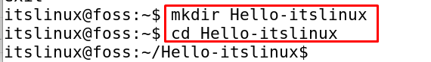
Then we will create a YML file here with the help of the nano editor using a command:
$ nano docker-compose.yml
Type some content here let’s say we are going to initialize two services db and WordPress, both the services will create their own images when executed by the Docker-Compose. The code of this will be as:
version: '3'

services:
db:
image: mysql:5.7
volumes:
- db_data:/var/lib/mysql
restart: always
environment:
MYSQL_ROOT_PASSWORD: somewordpress
MYSQL_DATABASE: wordpress
MYSQL_USER: wordpress
MYSQL_PASSWORD: wordpress

wordpress:
depends_on:
- db
image: wordpress:latest
ports:
- "8000:80"
restart: always
environment:
WORDPRESS_DB_HOST: db:3306
WORDPRESS_DB_USER: wordpress
WORDPRESS_DB_PASSWORD: wordpress
volumes:
db_data:
Press CTRL+S to save the file and CTRL+X to exit the editor, now execute the file using the docker-composer as:
$ sudo docker-compose up -d
Now the above command will build up both; db and WordPress containers and also run them. Now if we want to remove and stop the containers using the docker-compose, execute the command:
$ sudo docker-compose down
We can also build a multi-container application using the Docker-Compose, a simple example is being considered for this purpose, again open a file using the nano editor and insert a new code in it.
$ nano docker-compose.yml
Now edit the code in which each section of the “Services” section will create a separate entry on the execution of the docker-compose as:
version: '3'

services:
distro:
image: alpine
restart: always
container_name: Alpine_Distro
entrypoint: tail -f /dev/null
Save the file by pressing CTRL+S and exit the editor by pressing CTRL+X. Once the editor is closed, execute the command to build the containers.
$ sudo docker-compose up -d
The containers have been buildup, to check the status of the containers executes the command:
$ sudo docker ps

Now to remove them, we will use the down command as:
$ sudo docker-compose down
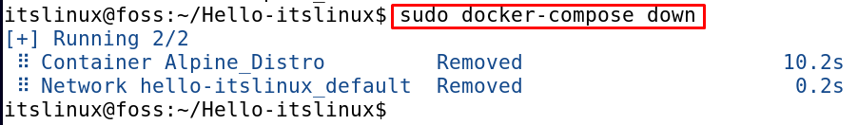
There are a lot of other advanced commands too with the help of which we can perform many other tasks. If we want to remove the Docker-Compose from Debian 11, run the command:
$ sudo rm /usr/local/bin/docker-compose
The Docker-compose has been removed from Debian 11 successfully.

Conclusion
Multi environments can be hosted from a single machine using the Docker-compose, which is the tool of the Dockers. It is very secure while communicating the information between the containers as it keeps the information in the form of a swarm. In this write-up, we first discussed the method of installation of Docker-Compose in Debian 11 directly from Github, and then we discuss its uses by building the two services db and WordPress and also building a simple application using the Docker-compose.
https://itslinuxfoss.com/install-use-docker-compose-debian/

